

For Perfect Kits to Fit Your Needs

* TLS Detox Kit

*Process Food/Poor Digestion*

* TLS 30 Day Jump Start Kit

*To Jump Start Weight Loss Journey*



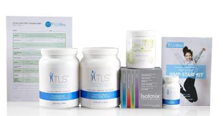

**TLS Detox Kit Contain:**

1 Select Aloe

1 NutriClean Fiber Powder ( 28 Servings)  
1 Choice Curcumin

**TLS Stay Fit Kit Contain:**

1. TLS Nutrition Shake (Chocolate & Vanilla) (14 Servings)
2. NutriClean Fiber Powder ( 28 Serving)

1 TLS CORE ( 30 Servings)

1. Isotonix Daily Essential Packets ( 30 Packet)

1 TLS 30 Day Jump Start booklet

1 TLS 30 Day Jump Start Menu Plan  
 1 TLS 30 Day Workout Booklet

**COST | SGD $200.50**

**COST | SGD $323.25**

* Fast Start Kit

*Become an Entrepreneur And begin creating on going income*

* TLS Stay Fit Kit

*To stay the Course and stay fit.*

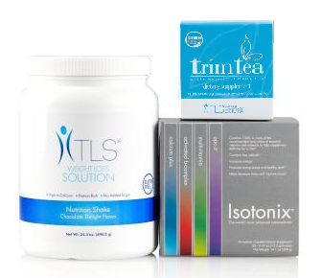

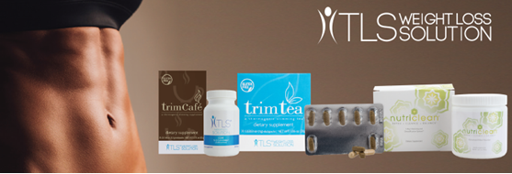

**TLS Stay Fit Kit Contain:**

1 Trim Tea (30 packets)

1 TLS Nutrition Shake (Chocolate or Vanilla) (14 Servings)

1. Isotonix Daily Essential Packet (30 packets)

**COST | SGD $238.00**

**COST | SGD $575.00**

Credit Card Purchasing Option:

Name______________________________ Phone ___________

Address _____________________________________________

City _________________________State _____ Zip ___________

Email ________________________________________________

Card Number ____________________ Exp Date(MM/YY)______

Signature _____________________________________________

**For optimum wellness take advantage of the auto shipment option and save an additional 5% discount?**

**Yes __ / No__**